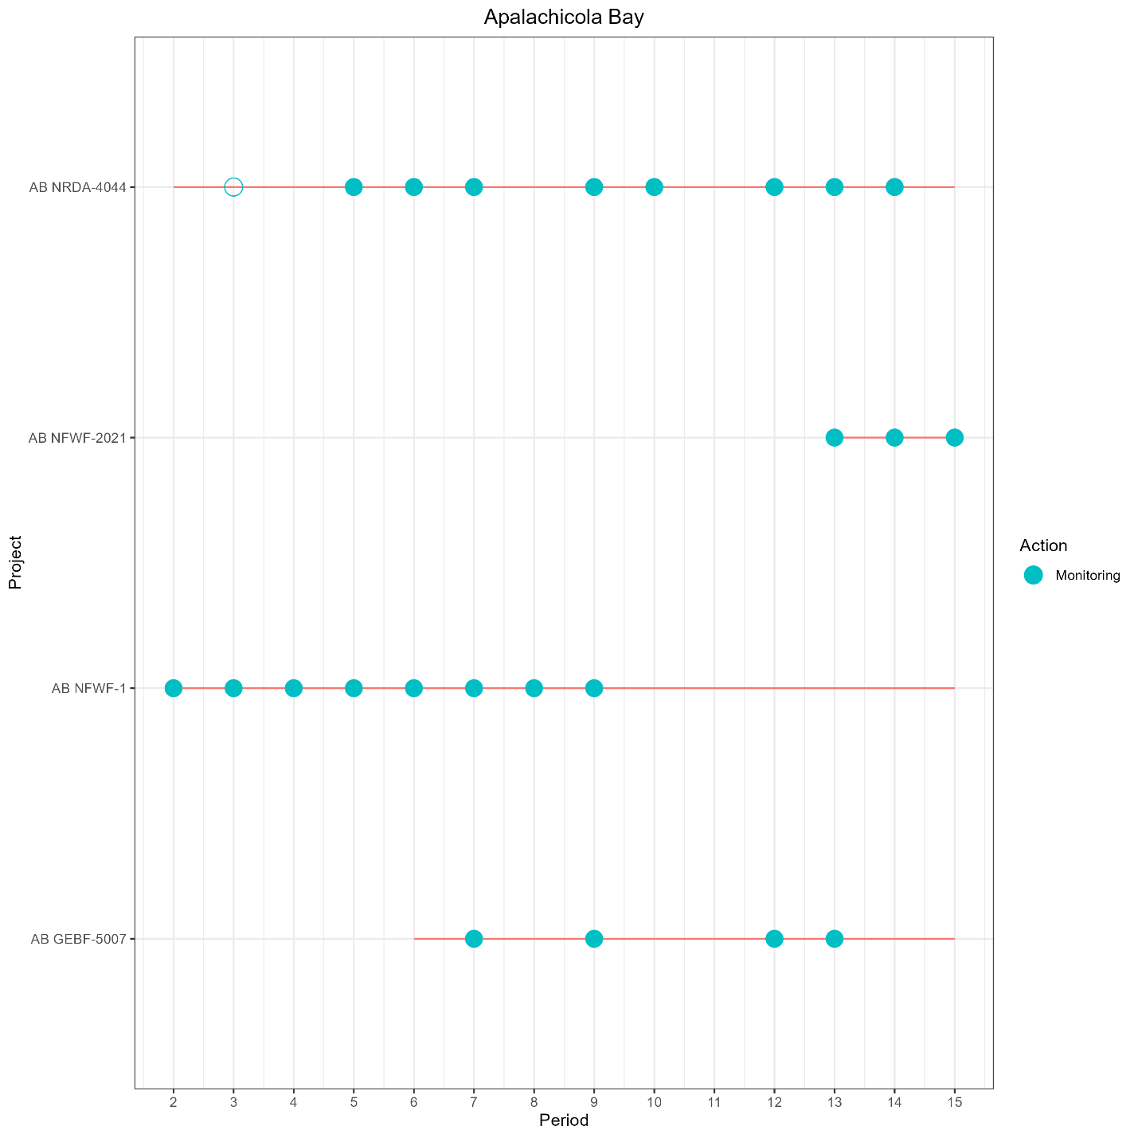

Figure 3. A schematic demonstrating the placement and persistence of cultch material by project (y-axis, red line) over time (x-axis) and the sampling events (grey circles) that collected oyster count data from each project. Project AB (Apalachicola Bay) NRDA-4044 only collected samples from one site in Period 3 (open circle) and sampling did not begin on other sites until Period 5. Even number periods include the months October-March beginning in 2015 and odd-number periods are summers months April-September beginning in 2016.